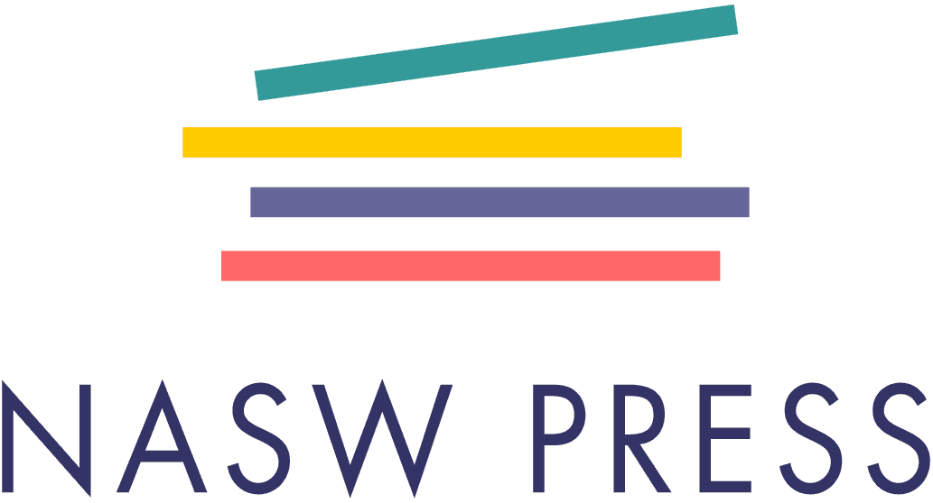
BOOK PROPOSAL PACKET

TITLE AND SUBTITLE:

AUTHOR(S)/VOLUME EDITOR(S) AND DEGREE(S):

Instructions: Thank you for your interest in NASW Press, the official press for the National Association of Social Workers. Please provide the title and names of all authors or volume editors in the spaces above. This packet has two parts: “Prospectus” and “Required Attachments.”

- Part 1, “Prospectus,” contains questions that are divided into three sections: author information, book information, and market information. Please provide answers in the white space below each question. It is important that you answer all questions marked required and that the prospectus not exceed 9 pages.

- Part 2, “Required Attachments,” outlines information about the essential materials to be included in your proposal packet. Please consult the Proposal Packet Checklist at the end of Part 2 to ensure that you are submitting all of the necessary pieces for our consideration.

If you have any questions about any of the items in this packet, please contact Acquisitions Editor Rachel Meyers at rmeyers.nasw@socialworkers.org. Thank you for your interest in NASW Press. We look forward to learning about your book!

PART 1: PROSPECTUS
Section I: Author Information
- Please list the preferred contact information for each author. Please include at least a home mailing address, email address, and phone number. (required)
- Please list all affiliations and professional memberships for each author. (required)
- Please list any relevant works published by each author. (required)
- Please describe briefly why this author or author team is an authority on this topic. Please feel free to outline relevant experience, including research or professional activities. (required)
- Diversity is crucial to the success of NASW Press, and we are committed to attracting and publishing authors from diverse backgrounds. Is there anything NASW Press should know about you that would inform our DEI initiatives, engagement, or awareness? (optional)

Section II: Book Information
- In 2–4 paragraphs, describe the content, specific goals, and overall purpose of this book. (required)
- What is the estimated length of the manuscript? Please calculate this number using double-spaced 8 ½ x 11 pages with 1-inch margins and typed in 12-point Times New Roman font. This estimate should include in-text citations and end-of-book references, author and contributor bios, acknowledgments, and figures and tables. We understand that exact pages are not easy to calculate and only ask for a rough estimate. NASW Press does not accept manuscripts of more than 325 pages. (required)
- Please provide an estimated submission date. (required)
- What impact will this book have on the field of social work? (required)
- If you know of any experts on this topic who might be able to provide an objective review of this proposal, please list them and their area of expertise below. If you are acquainted with your suggested reviewers, please also state your relationship with them. In the interest of fairness, NASW Press trusts prospective authors to take reasonable measures not to interfere in the review process should a suggested reviewer below be selected.
Name | Affiliation | Area of Expertise | Relationship w/Author (if applicable) | Contact Info

Section III: Market Information
- Please discuss the primary and secondary audiences. Who will use this book? How will it be used? (required)
- Do you believe that this book has textbook potential? If so, please list the types of courses this book might be used in and indicate whether you believe it would be used as a core or supplemental text.
List name or type of course here: | Core or supplemental? (Please check one.)
 | ☐Core ☐Supplemental
 | ☐Core ☐Supplemental
 | ☐Core ☐Supplemental

- If you believe your book has textbook potential, please describe in-text features that will facilitate student learning (e.g., learning objectives, chapter summaries, quizzes, suggested readings).
- For books with textbook potential, we would explore the development of a companion teaching manual to aid adopters and improve sales potential. A manual would include resources such as in-class and online exercises, assignments, and quizzes with answers. Please check all that apply:
_____ I would be willing to develop a teaching manual.
_____ I know someone that could co-author a teaching manual. Please list the name of the author:
____________________________
_____ I would be willing to identify someone to develop or co-author a teaching manual.
_____ I would work with someone identified by NASW Press to develop a teaching manual.
_____ My proposed textbook does not need a teaching manual. Explain: ______________________
____________________________________________________________________________

- Please list competing books in the field below and explain briefly how the proposed book would be unique compared to each one. (required)
Title: | Author: | Publication Date: | Publisher:
How is the proposed title unique or superior to this book?

Title: | Author: | Publication Date: | Publisher:
How is the proposed title unique or superior to this book?

Title: | Author: | Publication Date: | Publisher:
How is the proposed title unique or superior to this book?

- Are you acquainted with any prominent voices in the field who might be willing to support this work by providing endorsements or even a contributing element such as a Foreword or Afterword?
- Are there any newsworthy or important events that might serve as key marketing opportunities for this book? (Please keep in mind that the production process can take up to four or five months after manuscript submission.)
PART 2: REQUIRED ATTACHMENTS
To adequately review your proposal packet, we will need the following materials to be submitted with the above prospectus:

- Annotated table of contents/book outline
This goal of this document is to give the acquisitions department and reviewers a clear picture of the content’s flow and organization. This document is composed of a table of contents in which the title of each element (such as a section, chapter, appendix, glossary, etc.) is followed by a brief explanatory narrative about the content. (Each narrative should ideally be no more than 3–4 sentences in length.) Any contributing authors should also be listed under their respective chapters.

- One or two sample chapters
This essential piece is evaluated for accessibility and readability for the intended audience. For this reason, we require authors to submit no less than one sample chapter and no more than two sample chapters for review. Introductions and prefaces will not be considered chapters and may only be submitted in addition to a sample chapter or chapters.

- A curriculum vitae for each book author (or volume editor, if applicable)

Please contact Acquisitions Editor Rachel Meyers (rmeyers.nasw@socialworkers.org) with any questions.

PROPOSAL PACKET CHECKLIST
Before submitting, have you included all of the following required materials in your proposal packet?
☐ | Filled-out prospectus that does not exceed 9 pages (with all required questions answered)
☐ | Book outline/annotated table of contents
☐ | At least one sample chapter
☐ | Curriculum vitae for each author

